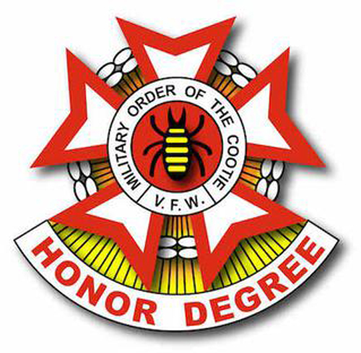

Greetings from Old Man Mountain Pup Tent #1 New Hampshire! We are reaching out to you today for a donation of a gift card or money. Read on to find out why!
The Military Order of the Cootie of the United States (MOC), founded in 1920, is a non-profit Veterans Service Organization. We are known as "The Honor Degree of the VFW" and our members are comprised of the officers and leadership of the Veterans of Foreign Wars of the United States. Our service program is described as a directive to "Keep 'em Smiling in Beds of White." Each year we volunteer our time to the Manchester VA Hospital and the New Hampshire Veterans Home. We also support the VFW National Home for Children in Eaton Rapids, Michigan, which was the brainchild of the MOC.
Because of COVID, we have been unable and continue to be unable to go to hospitals, the Veterans Home, and the National Home for visits and events for the residents. We are instead donating money to these facilities to support their in-house recreation programs. We are reaching out to you today for a donation of a gift card which we will use as a prize for participants in our upcoming fundraiser, a Cootie Cornhole Tournament, to be held in conjunction with the Fifth Annual Veterans appreciation Picnic on September 25 at the Hudson VFW Post 5791. Monetary donations would be used to purchase food and drink for the Tournament.
We would appreciate your support in any amount. Thank you for your consideration.

Regards,

Christina Madden

Seam Squirrel
M.O.C.
Old Man Mountain Pup Tent #1 NH

